# Assignment 2

**Q1) Create a Web page using HTML to demonstrate various CSS selectors including Universal, Type, grouping (element based), Class, Id.**

**Source-Code:**

**Assignment2_1.html**

<html>

<head>

<title>Assignment1_1</title>

<style>

.uppercase{text-transform: uppercase;font-size:11px}

p#p1 {color:#3399FF;font-size:17px;font-style:italic}

p#p2 {color:#000033;font-size:20px;font-style:italic}

p.p3 {font-size:23px;text-align:center}

h2.h2 {color:#003366;font-style:italic;font-weight: bold;font-family:Calibri}

h2 em{color:#0099FF}

h4{font-weight:bold;font-size:15px}

div * {font-weight:bold;}

h2,h3{font-family:Times New Roman}

</style>

</head>

<body>

<p class="uppercase">id</p><hr>

<p id="p1">CSS Using ID 1</p>

<p id="p2">CSS Using ID 2</p>

<p class="uppercase">class</p><hr>

<p class="p3">CSS Using Class</p>

<p class="uppercase">descendent</p><hr>

<h2 class="h2">This headline is <em>very</em> important</h2>

<p class="uppercase">grouping</p><hr>

<h2>H1 and H2 are being grouped<h2>

<h3>the meaning is same as using the property of separate element</h3>

<p class="uppercase">type</p><hr>

<h4>a type selecter matches the name of a document language element type</h4>

<p class="uppercase">universal selector</p><hr>

<div><p>CSS using Universal Selector</p></div>

</body>

</html>

**Output:**

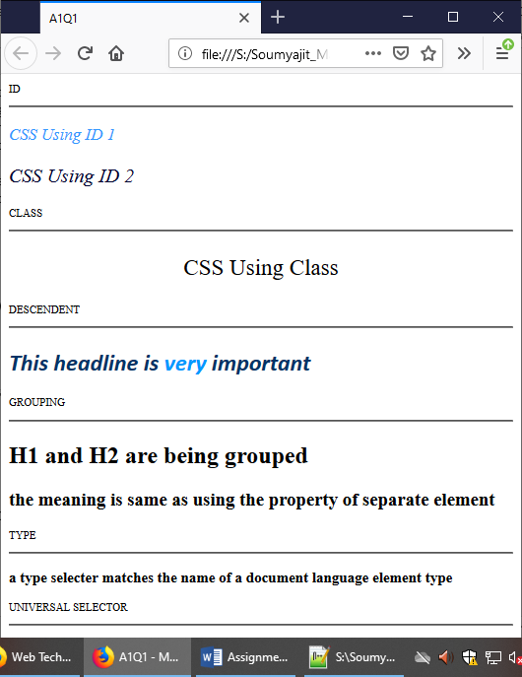

**Q2) Create a Web page to demonstrate Inline Styles, Embedded Styles and External Stylesheet.**

**Source-Code:**

**Assignment2_2.html**

<html>

<head>

<title>Assignment2_2</title>

<link rel="stylesheet" type="text/css" href="Assignment2_2.css">

<style>

body {text-align:center;}

h2 {color: White;margin-left: 40px;}

</style>

</head>

<body>

<!--External-->

<h1>This is a heading1!</h1>

<!--Embeded-->

<h2>This is a heading2</h2>

<!--Inline-->

<h1 style="color:lightgrey;">This is a heading1</h1>

<p style="color:pink;">This is a simple paragraph.</p>

</body>

</html>

**Assignment2_2.css**

body{ background-image: linear-gradient(50deg,#3498db,#8e44ad);}

h1 {color: navy;font-style:italic;}

**Output:**

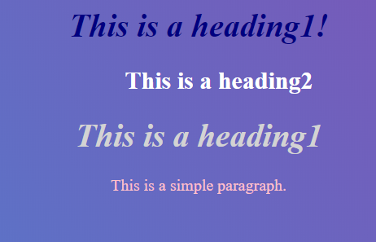

**Q3) Demonstrate the use of Pseudo Classes in CSS specifically for: hover, visited, active, link and focus.**

**Source-Code:**

**Assignment2_3.html**

<html>

<head>

<title>Assignment2_3</title>

<style>

/* unvisited link */

a:link {

color: red;

}

/* visited link */

a:visited {

color: green;

}

/* mouse over link */

a:hover {

color: cyan;

}

/* selected link */

a:active {

color: blue;

}

/* selected link */

a:focus{font-size:40px;}

</style>

</head>

<body>

<p><b><a href="https://www.google.com">This is a link</a></b></p>

</body>

</html>

**Output:**

Visited link

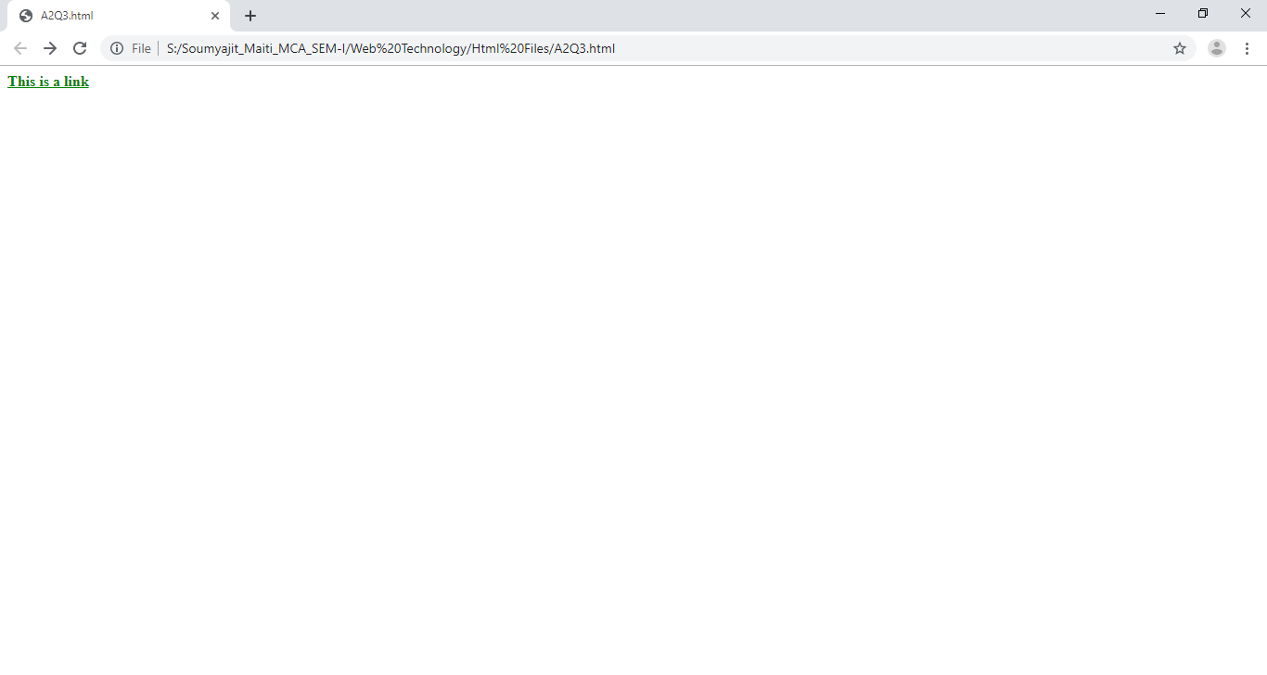

Hover

C:\Users\hp\Pictures\Screenshots\Screenshot (336).png

Focus

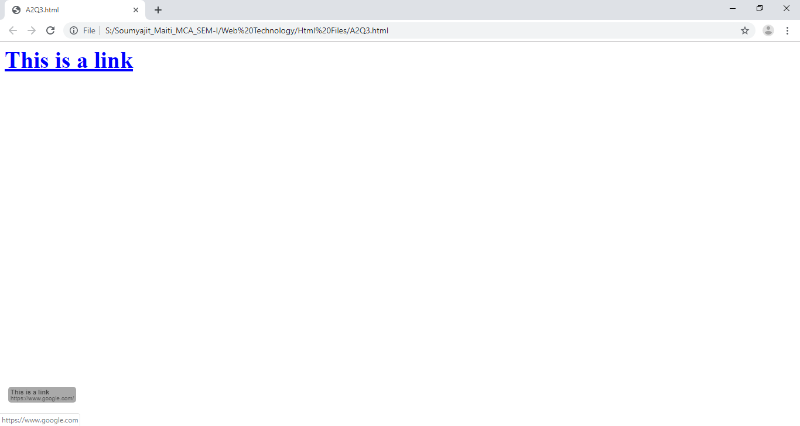

Link

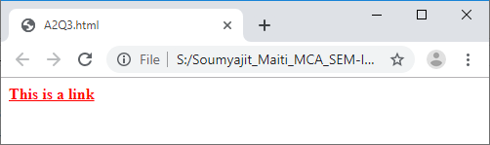

**Q4) Create a Web page to demonstrate various CSS Properties for Font.**

**Source-Code:**

**Assignment2_4.html**

<html>

<head>

<title>Assignment2_4</title>

<style>

p {

font-family:Calibri;

font-size:45px;

color:blue;

font-weight:bold;

font-style:italic;

}

</style>

</head>

<body>

<p>Various CSS Properties for Font </p>

</body>

</html>

**Output:**



**Q5) Create a Web page to demonstrate various CSS Properties for Text.**

**Source-Code:**

**Assignment2_5.html**

<html>

<head>

<title>Assigntment2_5 </title>

<style>

h1

{

letter-spacing:5px;

color:#0033cc;

text-indent:35px;

font-size:15px;

}

h2

{

letter-spacing:3px;

color:#0033cc;

text-indent:35px;

font-size:15px;

}

h3

{

letter-spacing:-1px;

color:#0033cc;

font-size:15px;

}

h4

{

line-height:normal;

color:#0033cc;

font-size:15px;

}

h5

{

line-height:60%;

color:#0033cc;

font-size:15px;

}

h6

{

line-height:210%;

color:#0033cc;

font-size:15px;

}

h7

{

font-size:15px;

text-transform:uppercase;

color:#0033cc;

text-indent:35px;

}

h8

{

font-size:15px;

text-transform: lowercase;

color:#0033cc;

text-indent:35px;

}

h9

{

font-size:15px;

text-transform: capitalize;

color:#0033cc;

text-indent:35px;

}

h10

{

letter-spacing:25px;

color:#000033;

text-indent:35px;

font-size:15px;

}

h11

{

letter-spacing:10px;

color:#0033cc;

text-indent:35px;

font-size:15px;

}

h12

{

letter-spacing:-1px;

color:#0033cc;

text-indent:35px;

font-size:15px;

}

</style>

</head>

<body>

<h1>This paragraph is of 5px letter spacing</h1>

<h2>This paragraph is of 3px letter spacing</h2>

<h3>This paragraph is of -1px letter spacing</h3>

<p><b><font color="#0033cc">Standard/Default line-height:-</b></p>

<h4>This is a paragraph with a standard line-hieght.<br>The default line height in most browsers is about 110% to 120%.</h4>

<p><b><font color="#0033cc">Small line-height(60%):-</b></p>

<h5>This is a paragraph with smaller line-height.<br>This is a paragraph with smaller line-height.</h5>

<h6>This is a paragraph with a bigger line-height.<br>This is a paragraph with bigger line-height.</h6>

<p><font color="#000033"><font size="5"><p align="center">CSS Text</p>

<p><p align="right"><font size="3"><font color="#0033cc">This is CSS Text Handling Tutorial</p>

<p><font size="3"><font color="#0033cc">This is a paragraph that contains details about the CSS Text handling tutorial.<br>This is a paragraph with class="ex".This text is green.</p>

<p><p align="center"><font size="5"><font color="#000033">This is Main Heading</p>

<p><font color="#0033cc"><font size="3">This is an ordinary paragraph.Notice that this text is red.The default text-color for a page is defined in the body selector.

<p><font color="#0099ff"><font size="3">This is a paragraph with class="ex".This text is green.

<p><font color="#0033cc"><font size="3">This text is in default text direction</p>

<p><p align="right"><font size="3"><font color="#0033cc"> kvndlgne fnwvinw wefsd fweiwew.</p>

<p><p align="center"><font size="5"><font color="#000033">CSS Text</p>

<p><font color="#0033cc"><font size="3">This is a paragraph on CSS text</p>

<h7>Transformed into uppercase</h7></br><br>

<h8>TRANSFORMED INTO lowercase</h8><br><br>

<h9>transformed into captialize</h9><br><br>

<h10>This para is of 25px letter spacing</h10><br><br>

<h11>This para is of 10px letter spacing</h11><br><br>

<h12>This para is of -1px letter spacing</h12>

</body>

<html>

**Output:**

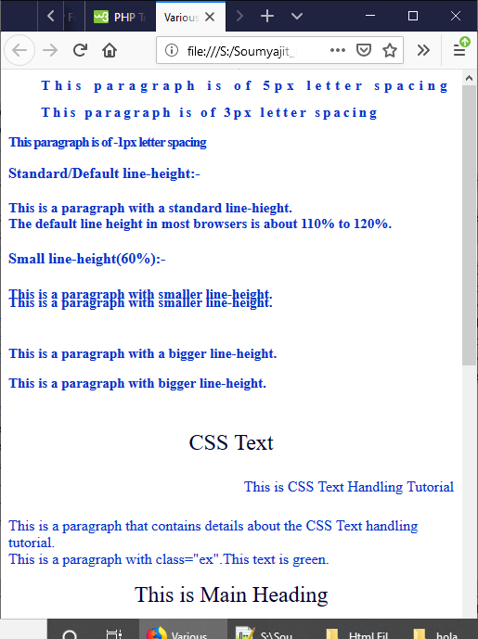

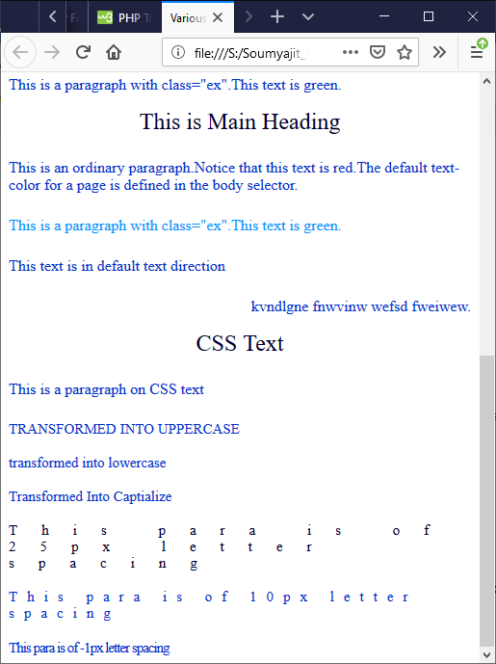

**Q6) Create a Web page to demonstrate various CSS Properties for background of any element.**

**Source-Code:**

**Assignment2_6.html**

<html>

<head>

</head>

<style>

h1{background-color:purple;width:480px;background-position:centre top;}

p{background-color:white;width:480px;font-family:Times New Roman;}

div{background-color:cyan;width:480px;font-family:Calibri;}

body{background-image:url("j.jpg"); background-repeat: no-repeat;}</style>

<body>

<h1>This is Heading1!</h1><br><br>

<p>This is edited using background property for Paragraph tag</p><br>

<div>This is div tag</div>

</body>

</html>

**Output:**

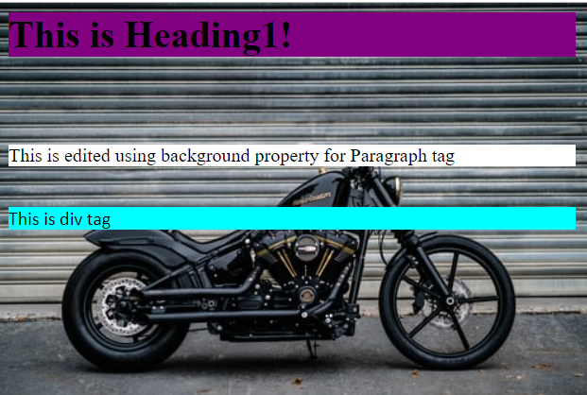

**Q7) Create a Web page to demonstrate various CSS Properties for border.**

**Code:**

<html>

<head>

<style>

p.dotted {border-style: dotted;border-width: 5px;border-color: red;}

p.dashed {border-style: dashed;border-width: medium;}

p.solid {border-style: solid;border-width: 2px 10px 4px 20px;border-color: red green blue yellow;}

p.double {border-style: double;}

p.groove {border-style: groove;}

p.ridge {border-style: ridge;}

p.inset {border-style: inset;}

p.outset {border-style: outset;}

p.none {border-style: none;}

p.hidden {border-style: hidden;}

p.mix {border-style: dotted dashed solid double;}

</style>

</head>

<body>

<center><h2>The border-style Property</h2></center>

<p class="dotted">A dotted border.</p>

<p class="dashed">A dashed border.</p>

<p class="solid">A solid border.</p>

<p class="double">A double border.</p>

<p class="groove">A groove border.</p>

<p class="ridge">A ridge border.</p>

<p class="inset">An inset border.</p>

<p class="outset">An outset border.</p>

<p class="none">No border.</p>

<p class="hidden">A hidden border.</p>

<p class="mix">A mixed border.</p></body></html>

**Output:**

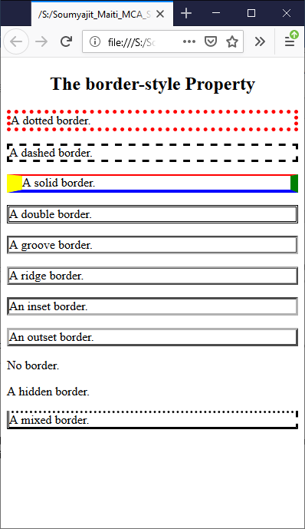

**Q8) Create a Web page to demonstrate various CSS Properties for Box Model including clear, display, float, height, width, margin, padding.**

**Code:**

<html>

<head>

<style>

.div1 {

text-align:center;

background-color: lightgrey;

width: 300px;

border: 15px solid green;

padding: 25px;

margin: 20px;

height:200px;

}

.div2 {

border: 1px solid red;

clear: left;

height: 100px;

}

.img1 {

float: left;

display: table;

}

</style>

<body>

<div class="div1">This text is the content of the box. We have added a 50px padding, 20px margin and a 15px green border.<br><br>

<img class="img1" src="img.png" alt="Image Error" width="170" height="100">

</div>

<div class="div2">This text is the content of the box. We have added a clear left and a 1px red border.

</div>

</body>

</html>

**Output:**

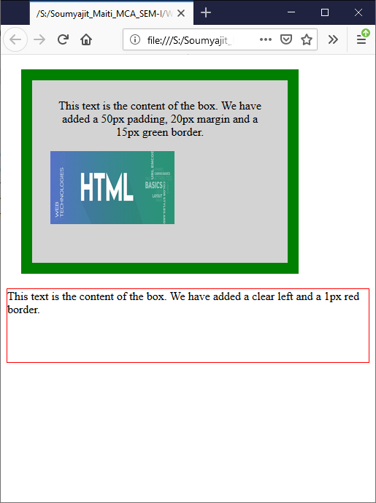

**Q9) Create a Web page to demonstrate CSS properties for Positioning of an element including bottom, left, position, right, top, z-index.**

**Code:**

<html>

<head>

</head>

<style>

.div{border: 3px solid #73AD21;height:300px;width:500px;}

.relative1 {

position: relative;

top: -10px;

left: 5px;

border: 3px solid #73AD21;

width:150px;

padding:5px;

}

.relative2 {

position: relative;

bottom: -177px;

left : 5px;

border: 3px solid #73AD21;

width:150px;

padding:5px;

}

.relative3 {

position: relative;

top: -128px;

right: -320px;

border: 3px solid #73AD21;

width:150px;

padding:5px;

}

.relative4 {

position: relative;

bottom: -60px;

right: -320px;

border: 3px solid #73AD21;

width:150px;

padding:5px;

}

.relative5

{

position: relative;

align:center;

top: -130px;

left: 155px;

border: 3px solid #73AD21;

width:150px;

padding:5px;

}

.img{position: absolute;height:300px;width:500px;z-index: -1;}

</style>

<body>

<div class="div">

<img class="img" src="index.jpg">

<p class="relative1">This is in the top left</p>

<p class="relative2">This is in the bottom left</p>

<p class="relative3">This is in the top right</p>

<p class="relative4">This is in the bottom right</p>

<p class="relative5">This is in the center</p>

</div>

</body>

</html>

**Output:**

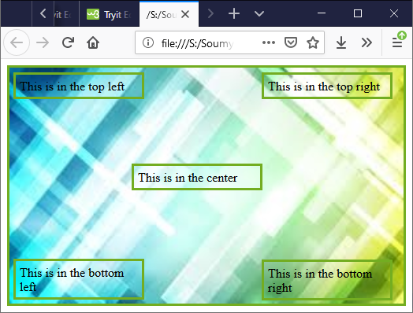

**Q10) Create a Web page to demonstrate the CSS properties for Outline various Styles.**

**Code:**

<html>

<head>

<style>

p {outline-color:#003399;}

p.dotted {outline-style: dotted;}

p.dashed {outline-style: dashed;}

p.solid {outline-style: solid;}

p.double {outline-style: double;}

p.groove {outline-style: groove;}

p.ridge {outline-style: ridge;}

p.inset {outline-style: inset;}

p.outset {outline-style: outset;}

</style>

</head>

<body>

<h2>The outline-style Property</h2>

<p class="dotted">A dotted outline</p>

<p class="dashed">A dashed outline</p>

<p class="solid">A solid outline</p>

<p class="double">A double outline</p>

<p class="groove">A groove outline. The effect depends on the outline-color value.</p>

<p class="ridge">A ridge outline. The effect depends on the outline-color value.</p>

<p class="inset">An inset outline. The effect depends on the outline-color value.</p>

<p class="outset">An outset outline. The effect depends on the outline-color value.</p>

</body>

</html>

**Output:**

